**Implementing regression using Rapid Miner**

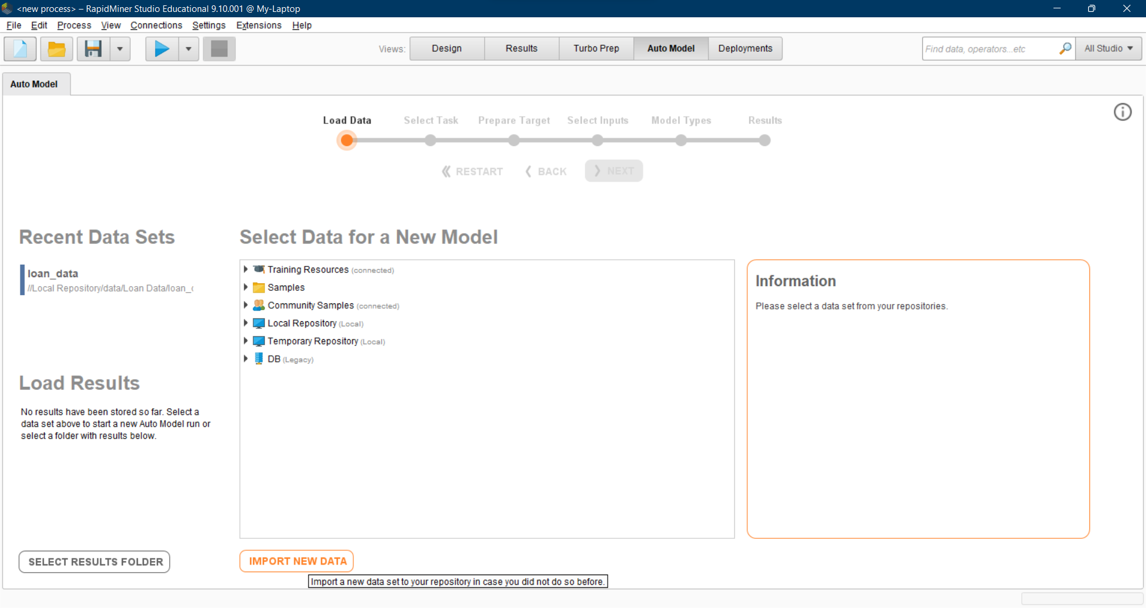

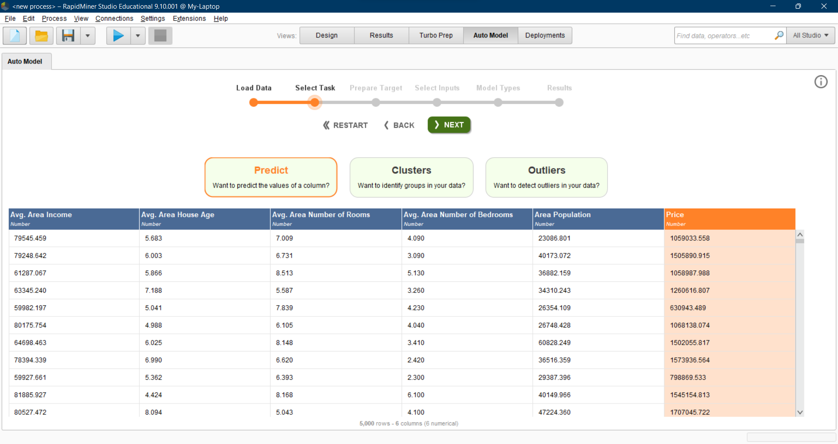

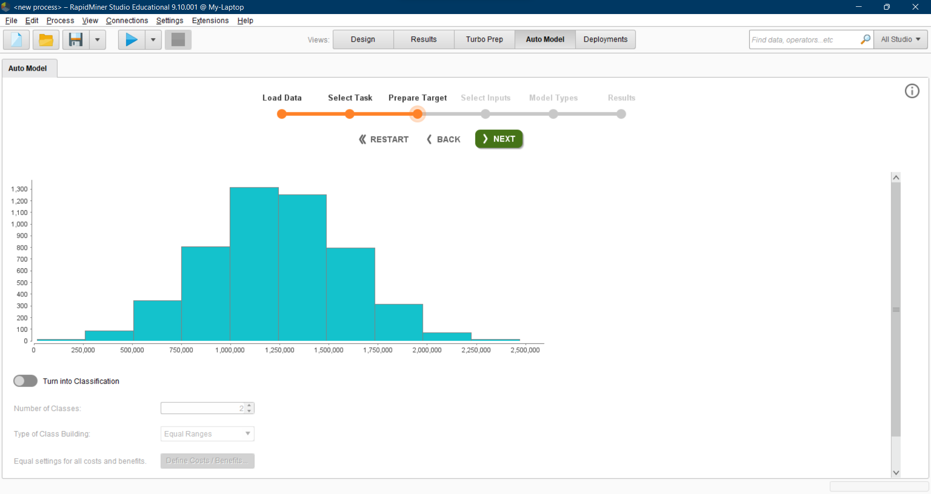

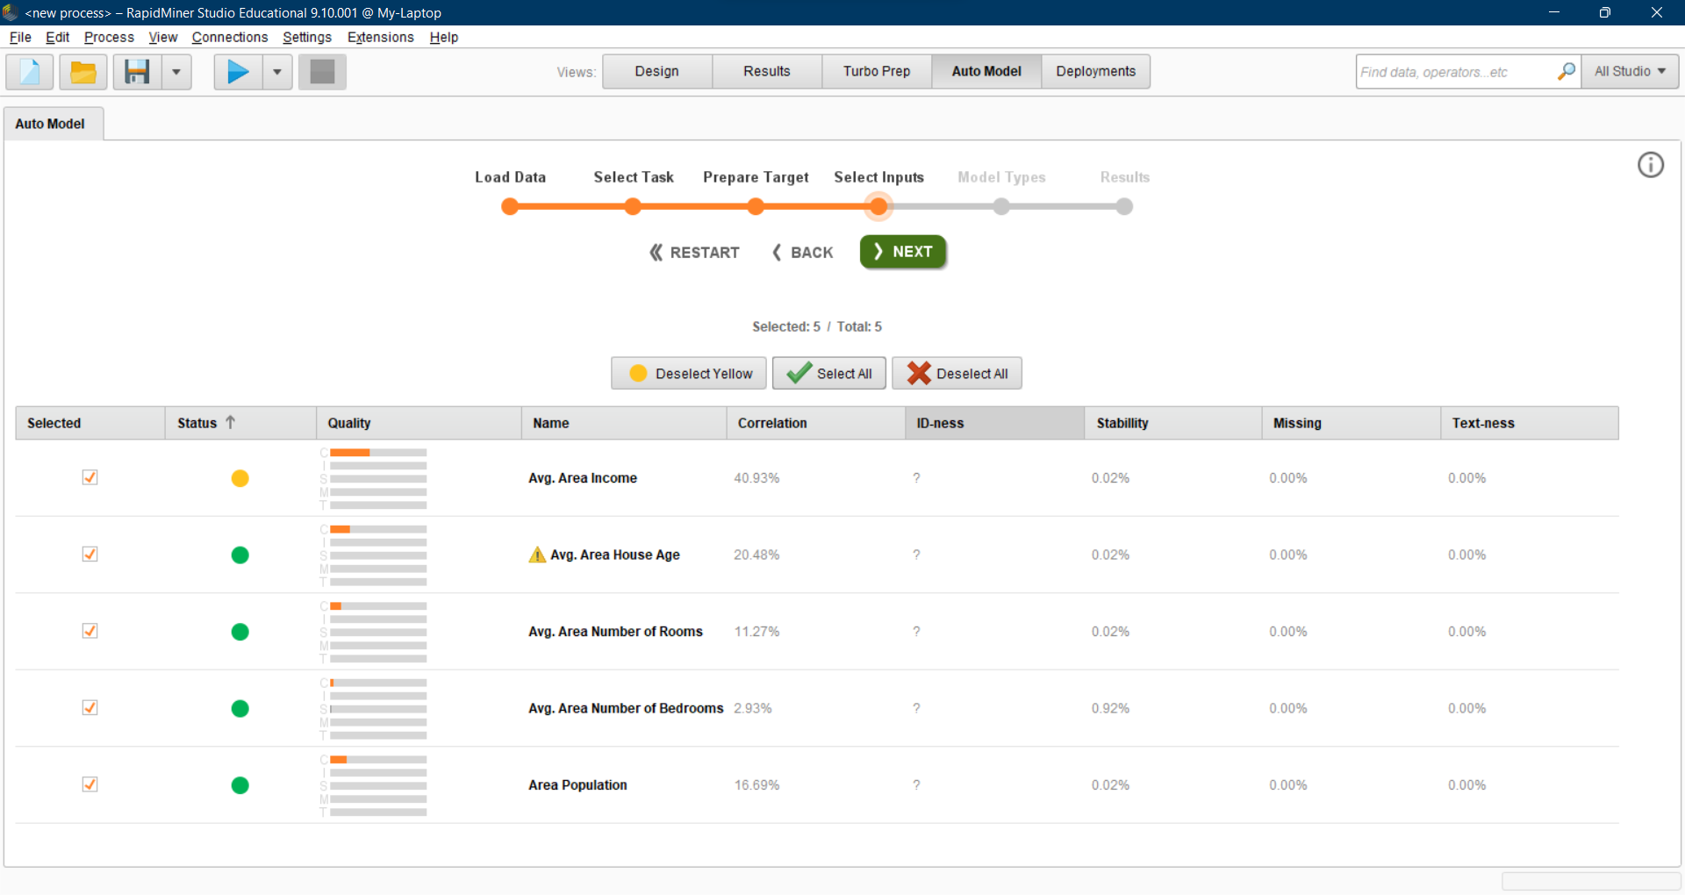

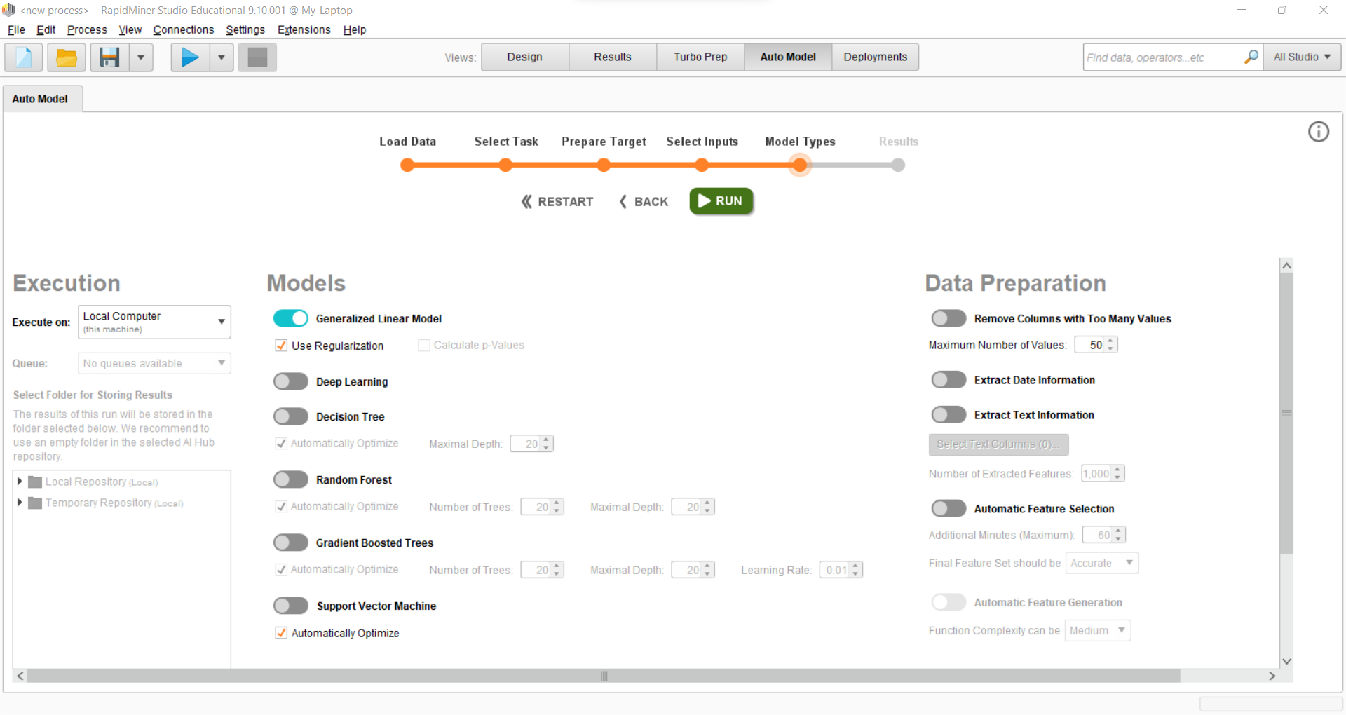

**Metrics:**

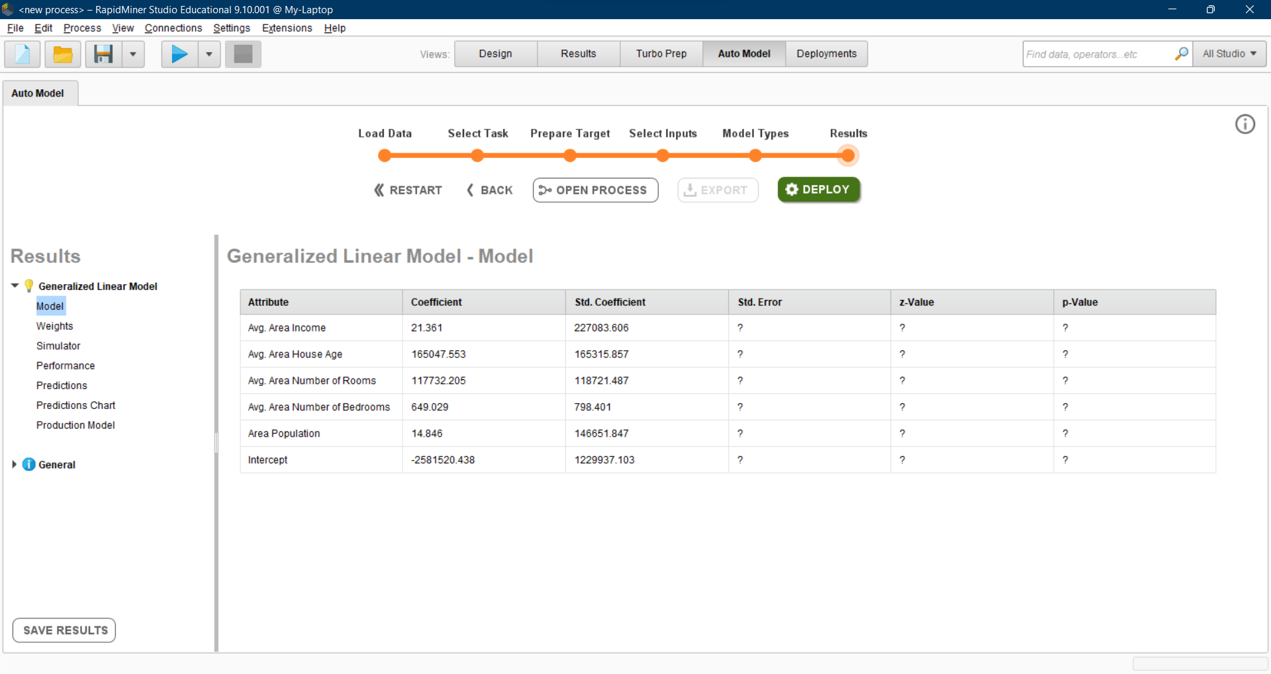

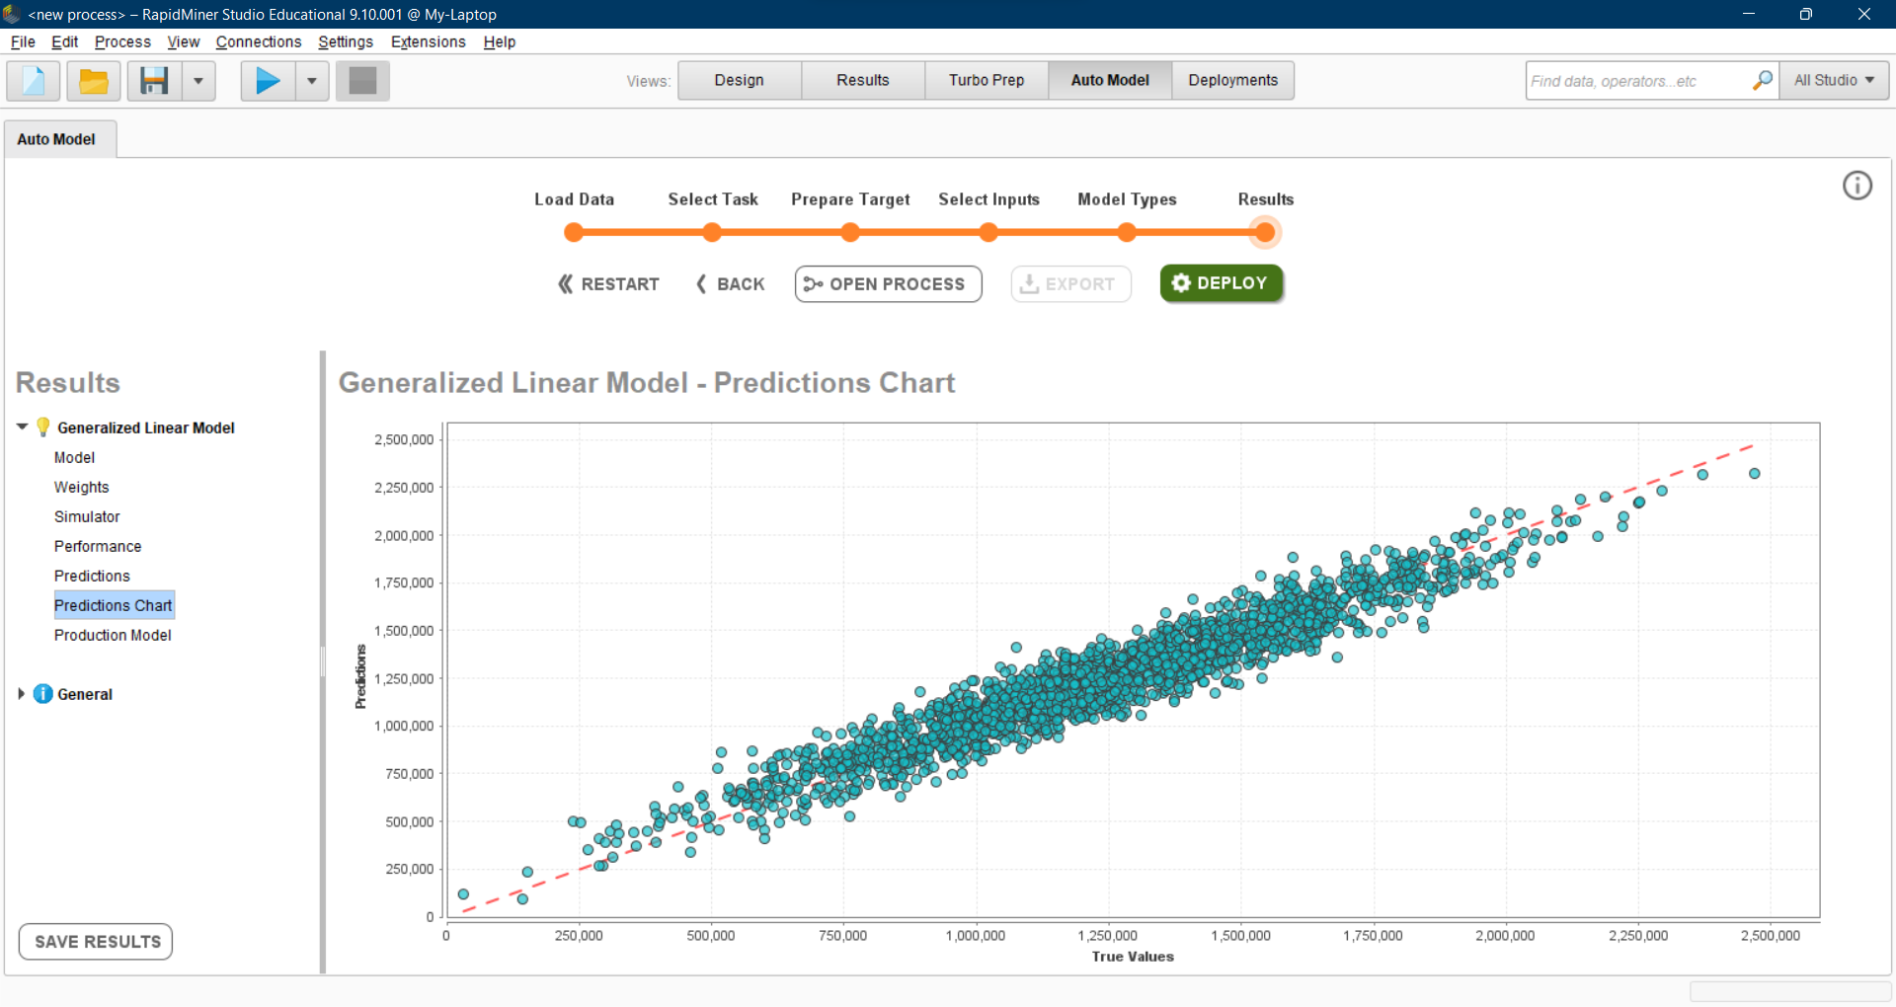

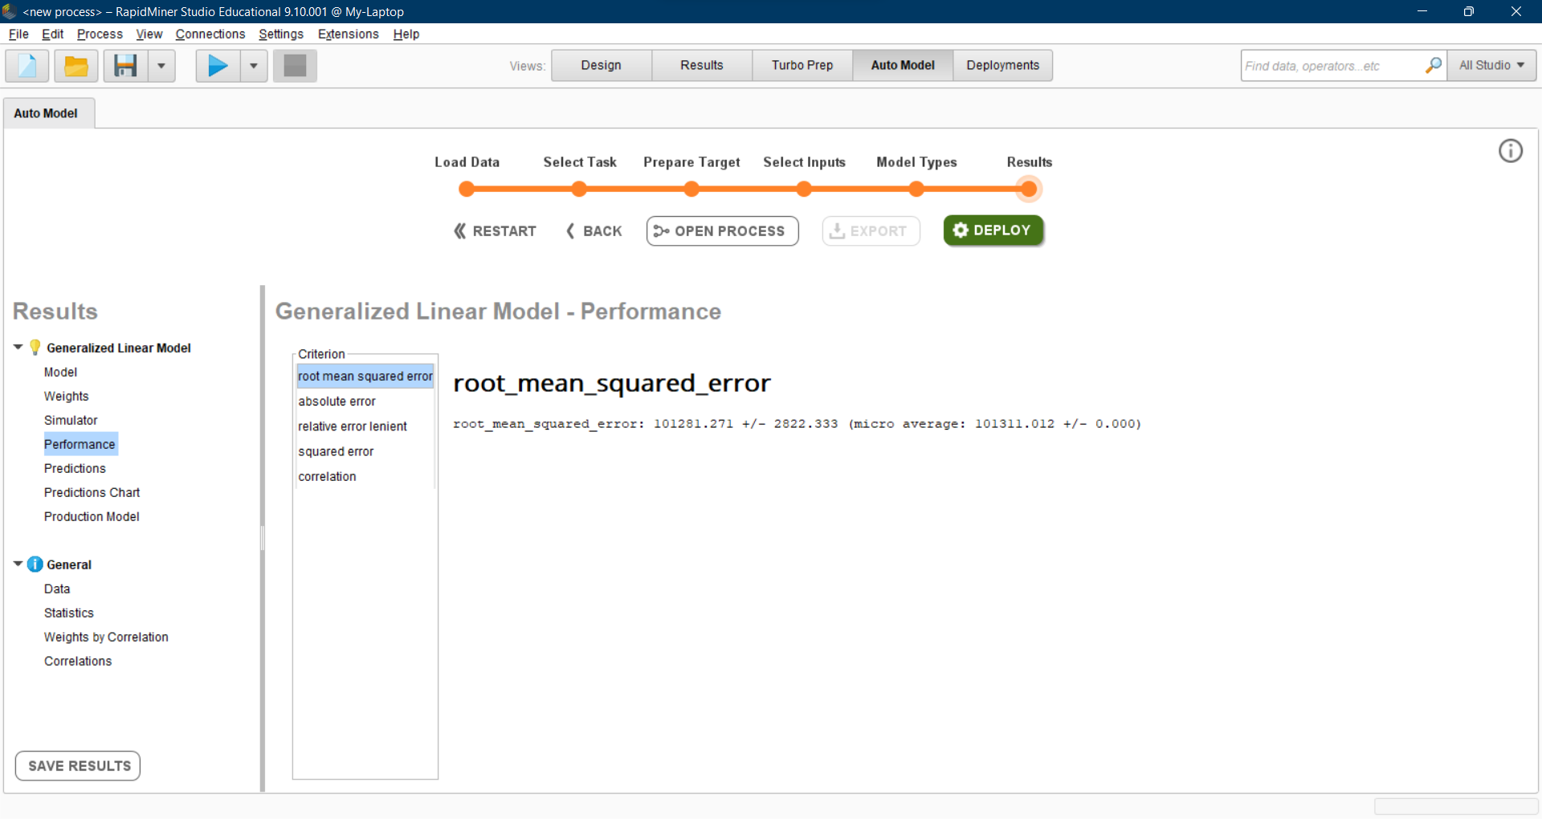

**Comparison of these implementations**

On implementing regression using Python libraries, RMSE = 102418.93

On implementing regression using RapidMiner, RMSE = 101281.27

Hence, the implementation using RapidMiner is better, because it has lesser RMSE value.

**Conclusion**

Thus we have learnt different ways to implement Linear Regression, and discovered that RapidMiner software gives the best results.